The Brontës
Next to Charles Dickens, Charlotte and Emily Brontë are the most widely read of English novelists. Charlotte’s Jane Eyre and Emily’s Wuthering Heights have found a place among the classics of the novel. In some respects their place in English literature is a remarkable one. Whereas with most writers the attention of the reading public is mainly focussed on their works, in the case of the Brontës it looks as if their fame is connected as much with the authors themselves as with their books. The story of their lives, so full of tragic intensity, has all the qualities of a Brontë novel, and many people have been fascinated with their background as well as with their novels.
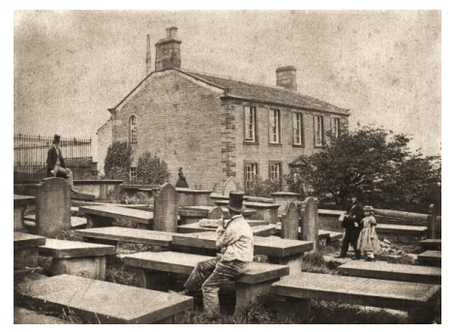
When the Reverend Patrick Brontë settled at Haworth in 1820, he brought with him his wife and six children: Maria, Elizabeth, Charlotte, Patrick Branwell, Emily Jane and Anne. The family’s first year at the parsonage also brought the first sorrows. Mrs Brontë died in the summer of 1821. Her place was taken by her sister Elizabeth Branwell, or aunt Branwell as she came to be called, who had helped to nurse her during her last months and was to stay with the family for the rest of her life. The Brontë children lived an isolated life. They did not mix with other children of the village, but kept to themselves. One of the villagers later remembered how ‘the six little creatures used to walk out, hand in hand, towards the glorious wild moors which in after days they loved so passionately’.
In 1824 Patrick Brontë decided it was time for his eldest daughters to receive a more formal education than he and Aunt Branwell could give them at home, and Maria, Elizabeth, Charlotte and Emily, who were then between six and eleven years old, were sent to the Clergy Daughters’ School at Cowan Bridge. The school was largely a charitable institution; discipline was strict, teaching unfriendly and living conditions poor.
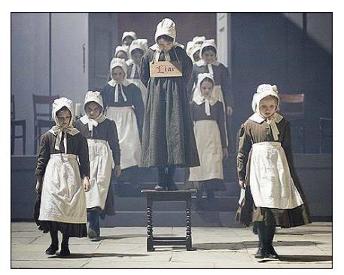
In Jane Eyre the school appears under the name of Lowood Orphanage and in describing Jane’s miserable stay there, Charlotte clearly drew on her own experiences at Cowan Bridge. The head of the school, the Reverend Carus Wilson, believed that poor girls should constantly be reminded of the low station in life, and should be taught to endure hardships without complaining. As a result, the girls often suffered cold, hunger and fatigue. Maria Brontë had never been in strong health, and life at Cowan Bridge proved too much for her. She developed tuberculosis and was brought home only to die a few days later. Elizabeth fell ill, too, and her death came just over a month after her sister’s.
The fate of his two eldest daughters left Patrick convinced that Charlotte and Emily would be better off at home, and for the next five years the four remaining Brontë children were together at the parsonage. They were often left to find their own amusements, and they spent their time wandering 36 across the moors, reading such books as their father’s library could provide and writing little plays, poems and stories.
The year 1847 saw the publication of Charlotte’s Jane Eyre, Emily’s Wuthering Heights and Anne’s Agnes Grey. Charlotte’s book was an immediate success. The story of the poor governess Jane Eyre and her love for her upper class employer Mr Rochester appealed to a large audience, and left literary circles in London guessing who this mysterious author Currer Bell might be.
Reactions to Wuthering Heights were mostly negative. The character of Heathcliff especially came as a shock to Victorian respectability. It was not until the end of the nineteenth century that people began to appreciate the outstanding merits of the book, and it is now generally considered superior to anything Charlotte ever wrote.
Anne’s novels were not of the same order as those of her sisters. If they are at all read today, it is because of the fame of her two sisters.
Tragedy hit the family again in 1848. Within a period a period of 10 months, Branwell, Emily and Anne died . Charlotte, the only remaining child, died in 1855 at the age of 39. Her father Patrick Brontë died in 1861. The Brontës’ parsonage in Haworth is now a museum, Charlotte’s and Emily’s novels are still read by many fans today and the stories have been turned into various plays, films and TV-series.

